**Election Campaign Materials:**

**Note: Our 120 GSM Php 24.50 Plain White Shirts is not available due to the reservations of large bulk orders.**

**Fabric: Cotton “ 130GSM (White Only)**

**UNISEX SIZES**

**Plain Shirts – Php 37.00 each**

**Shirt with Print front - Php 40.00 each**

**Shirt with Print Front and Back – Php 43.00 each**

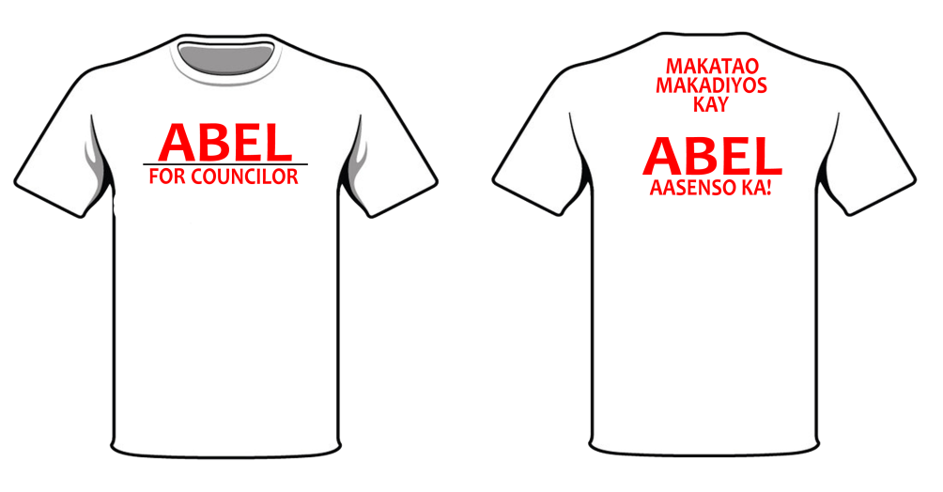

**Fabric: Cotton “ 140GSM (White Only)**

**UNISEX SIZES**

**Plain Shirts – Php 42.00 each**

**Shirt with Print front - Php 45.00 each**

**Shirt with Print Front and Back – Php 48.00 each**

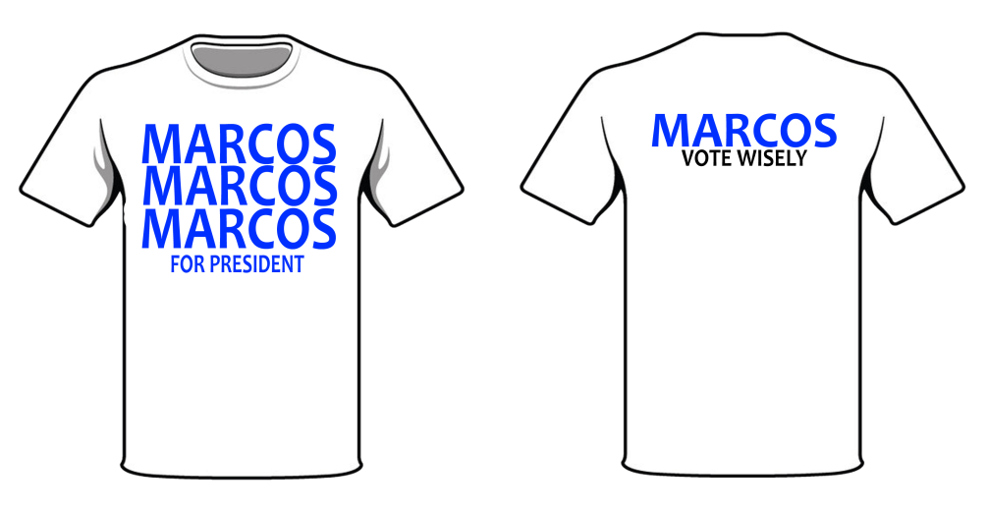

**Fabric: Cotton “ 180GSM (White Color)**

**Sizes: XS – XXL**

**Plain Shirts – Php 70.00 each**

**Shirt with Print front – Php 73.00 each**

**Shirt with Print Front and Back – Php 76.00 each**

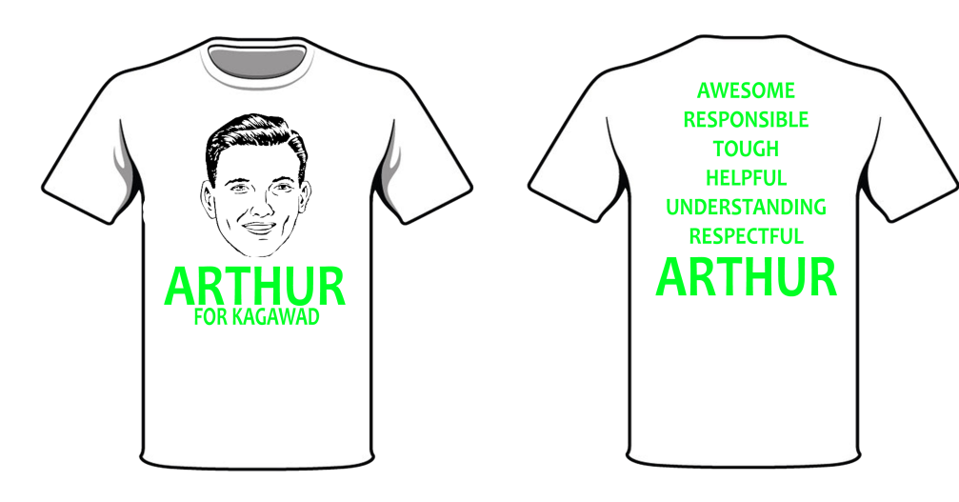

**Fabric: Cotton “ 180GSM**

**Sizes: XS – XXL**

**Colors Available:**

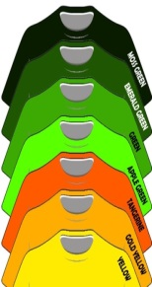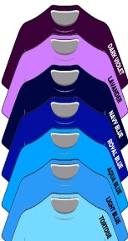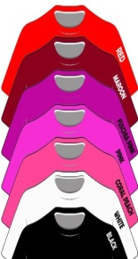**Plain Shirts – Php 80.00 each**

**Shirt with Print front – Php 83.00 each**

**Shirt with Print Front and Back – Php 86.00 each**

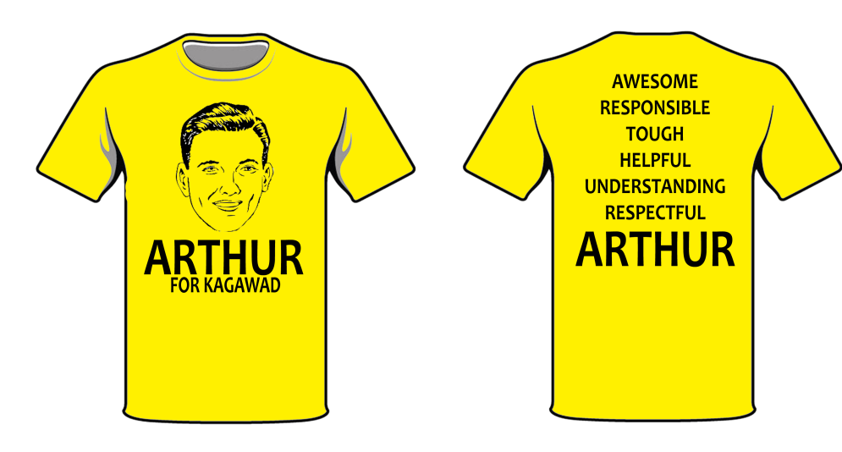

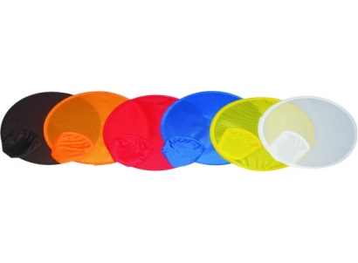

**Round Fans:**

**Colors Available: Red, White, Orange, Yellow, Blue, Black**

**Plain Round Fans: Php 5.00 each**

**Round Fans with Print: Php 7.00 each**

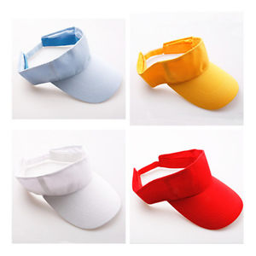

**Opened Caps:**

**Colors Available: Red, White, Orange, Yellow, Blue, Black**

**Plain Opened Caps: Php 40.00 each**

**Opened Caps with Print: Php 45.00 each**

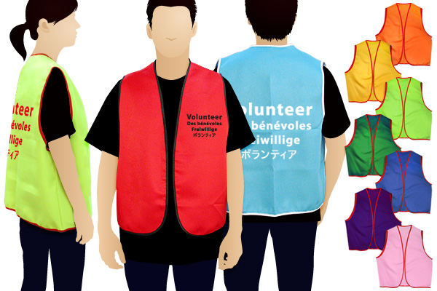

**Election Vest:**

**Colors Available: Red, White, Orange, Yellow, Blue, Black**

**Plain Election Vest: Php 130.00 each**

**Election Vest with Print: Php 140.00 each**